A friend of ours, who was wondering how to raise his children with a global Christian perspective, asked what our parents did that laid the foundation for a book-loving girl in braids from Wichita, KS and an adventure-seeking ball-of-energy from Tennessee to thrive in another country and culture.
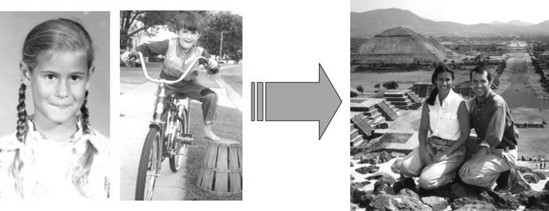
We thought you might enjoy seeing the ideas we wrote for him.

Learn
Read about people who are serving, or have served, God, particularly in a different culture. Our parents read missionary biographies to us in the car on long trips; now you can just stick in an audio tape. Remember there is a lot more out there than Amy Carmichael & Hudson Taylor. People who have been supporters of missions for years probably have old books you can’t find even on Amazon filled with fascinating stories of people the world has never heard of but who are legendary heroes in God’s history books.

Experience
Take advantage of the cultural classroom surrounding you everyday. Read National Geographic. Watch the Travel Channel. Eat at authentic ethnic restaurants (preferably where the menus have two languages and you order the recommendation of your waiter or waitress to whom English is a second language. ☺ You may never order it again but you’ll have a significant cross-cultural experience without paying any airfare.).

Be Hospitable
I couldn’t begin to name all of the missionaries who talked for long hours around our dinner table when I was a girl, but they all had a cumulative effect of showing me that God is doing exciting things all over the world.

But don’t limit yourself to the occasional missionary who comes through town. Get to know people from other countries who live near you. Ask them about their homeland, their families, their traditions. Be a host family for an exchange student or invite a foreign student to your home. From the many foreign students who have stayed with Tim’s family over the years, some have grown into valuable long-term friendships.

Travel
Short term mission trips are of course very valuable, but before I ever went on a short term trip I had visited missionaries where they lived and worked, stayed in their homes and been in their churches.

When you travel, be intentional about finding out what God is doing in the places you visit. Friends of ours recently took a trip to South Africa where they made contact with a friend of a friend who took them on a ministry outing to a local jail. It was the most memorable event of their vacation.

Pray
This can be as formal as working through Operation World: the day-by-day guide to praying through the world or as informal as praying for Christians in countries you see in the news. Tim’s family kept missionary letters and Christmas cards from friends in a basket by the dinner table. Every day they took a letter from the basket and prayed for that person and their needs.

Sponsor a Child
Dionisia and Efrosini were the girls my family sponsored. I prayed for them every night and was fascinated by the Greek letters on the front of the card with their pictures in them. Now we support children through Compassion International but I can’t help but think that my early exposure to the ministry then called American Mission to the Greeks was part of my lifelong love of all things Greek. As a girl I didn’t know about every country in the world, but whenever I heard something about Greece I listened because it had a connection with it.
Annette & Tim

