Spain…

First, if you remembered to pray for our Raíces (Roots) board meeting in Spain - thank you so much!
And second we apologize for our delay in reporting. [If you are interested in “real time” updates on our life and thoughts check out our web logs (“blogs”) which we update frequently. You can find the links to them at www.sepal.org/gulick ]

In short, the trip was both profitable and fun. We couldn’t have imagined how stimulating and refreshing it would be.


The stage for our meetings was set by the fact that we stayed inside of the Monserrat monastery. The beauty of the surroundings nourished us. And the palpable weight of a thousand years of imperfect people making an effort to obey and glorify God encouraged us (“Therefore since we are surrounded by such a great cloud of witnesses…let us run with perseverance the race marked out for us.” Romans 12:1) And it reminded us of God’s restraint and patience. Speed and efficiency are values to us, which I believe come from the limitations of our resources: time, energy, money, etc. Since God has no limitations, he doesn’t need to be in a hurry, so if we are working on his timetable we can afford to wait on Him.

Looking up at the serrated mountains encircling the monastery, which has never been completely destroyed though it has been attacked, sacked and even burned over the centuries, we inhabited a metaphor of Jesus’ words, “…on this rock I will build my church, and the gates of Hades will not overcome it.” (Matthew 16:18) This was a good reminder that God is the one who is building His church. He gives us the privilege and responsibility to be part of the process but ultimately its success or failure does not depend on us. (for more photos from this trip, go to www.sepal.org/gulick/Happenings.html and click on the “Barcelona & Montserrat” link)

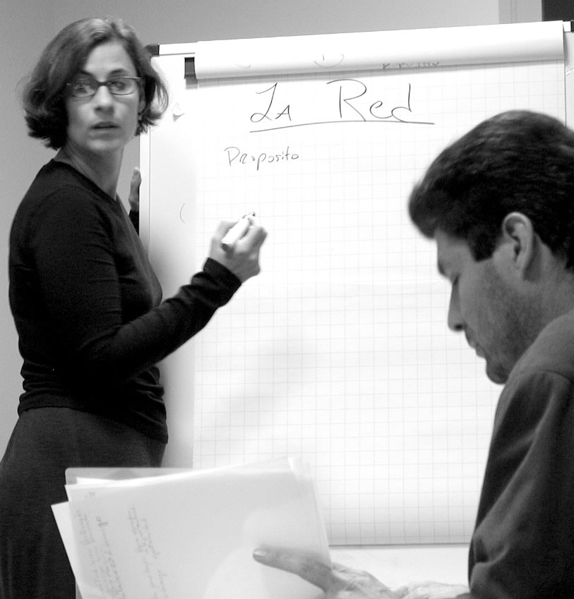
The refreshment of the location was a wonderful balance to the days of intense meetings. Raíces has undergone major upheaval since we joined the board almost three years ago so it was time to evaluate the past, asses the present and make plans for the future based on the new panorama. The future of the ministry of the “Roots” conferences, which has been its core in the past, is uncertain. Time will tell if some historic weaknesses (particularly in the areas of administration, communication and funding) can be overcome.

But what is certain is the potential for the youth ministry training course we’re developing based on the Roots manual. We’re almost two thirds of the way through with the development of the 20 classes and during the meeting in Spain we hammered out a plan to begin offering it online before the end of this year.

So although the long-term prospects for the ministry are not clear, our short-term goals are.

We want to have two thirds of the classes finished, programmed and published on CDs by the Raíces conference in Peru this July to provide the continuing education that has previously been provided through conferences.

We need to have the system in place to begin the online training using these classes by the fall.

Annette & Tim

