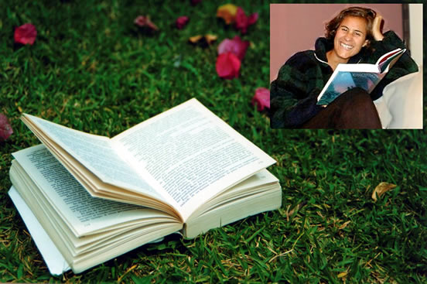
Summer Reading Recommendations

Blue Like Jazz: nonreligious thoughts on Christian spirituality by Donald Miller

This book reminds me why I love to read. Donald Miller is engaging, funny, vulnerable and has good things to say in a very fresh way. I first bought this book because it was only three dollars, had a cool cover and a quote on the back that interested me. After reading the first few chapters, I went back to the store and bought all of the remaining copies to give to friends. So you can judge a book by its cover ☺

Soul Survivor: how my faith survived the church by Philip Yancey

If you like Yancy, and even if you don’t, you’re in for a treat as he delves into the lives of thirteen people who have significantly influenced his life and thinking. These people range from the well known, like Martin Luther King Jr and Gandhi, to the more obscure, like the Japanese author Shusaku Endo. Each chapter is a multi-faceted gem as it introduces us to great men and women, lets us learn from their strengths and weaknesses, challenges us to reevaluate our lives and takes us along on Yancy’s own spiritual journey.

Girl meets God & Mudhouse Sabbath by Lauren F. Winner

Lauren is a skilled writer and (thanks to Greg Thompson, who gave it to Scott Murphy, who loaned it to us) we thoroughly enjoyed the story of her path from Reformed Judaism to Orthodox Judaism to Christianity in Girl meets God. It provided me with a lot of food for thought about the experiential way Jews incorporate their religion into their life and pass it on to the next generation, so I was pleased to come across her next book Mudhouse Sabbath (a signed copy, even, in a small bookstore in Blowing Rock, NC) which is about “…Christian practices that would be enriched, that would be thicker and more vibrant, if we took a few lessons from Judaism.”

Four Souls: a worldwide odyssey in search of the epic life

This book traces the adventures and insights of four friends who spend their first six months after college traveling the globe together, staying and working with Christians everywhere from Guatemala to Siberia to Vietnam. You can actually access the full text of the book online at www.foursoulsthebook.com
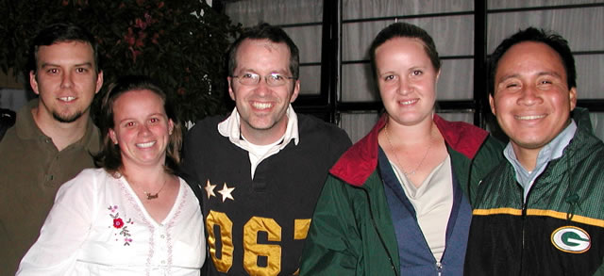

Our Summer

For us July means RAICES, youth leaders training conference. This year the conference is in Lima, Peru and not only will we be visiting a new country; we will be fulfilling a new role. As a result of some of the strategic planning we did in Spain in February, the continuing education part – training for trainers – of RAICES will no longer be an additional conference, but will be done through the animated, interactive classes we’ve been working on for the last year and a half.

It will take a major effort by at least five different people to get the CDs, containing with the classes, the text and the homework assignments, ready in time for the conference.

We appreciate your prayers for this process, as well as for our travel, the conference, and our ability to communicate this training process to the youth leaders in a way that is clear and that motivates them to continue their training.

