Recently several people have asked us what a normal day looks like for us. This makes us laugh because our life feels so not normal in many ways, but since this apparently is of interest to some people we thought it might interest you too.
A Day in our Life

Because we provide resources and training for youth leaders and people who train youth leaders throughout the entire Spanish-speaking world, we have two kinds of “normal” days: days at home and days when we’re traveling.

At Home
Home is for making progress on projects, for re-establishing contact with and encouraging members of our various teams and networks, and for recharging our personal batteries. Our days at home are largely spent working from the 6 x 9 ft. office in our 580 sq. ft. home.

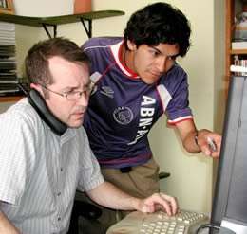
Tim’s computer is affectionately dubbed “the control center of the universe” because from there he communicates with the people in our life: co-workers, OC headquarters, friends, family, etc. A true multitasker, he’s always signed on to an instant messaging program which allows him to be in contact with many people working on a variety of projects at the same time.
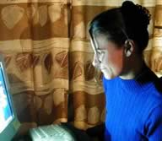
On the other hand, I, Annette, am a sequential unitasker; I prefer to work totally uninterrupted on one project at a time. My current project is preparing the content for the animated, interactive course, comprised of 22 classes, which provides comprehensive training in the foundational principles of pastoring youth. The course is already being used in several places around the continent so we need to finish everything, including a revision and redesign of the original 500-page textbook, as soon as possible!
During breaks in my work I manage the office environment by keeping hot tea and music ever-present. (George Winston, Oscar Peterson, Miles Davis and Café del Mar are on heavy rotation. We just discovered the Lounge Worship series which, despite sounding like an oxymoron, is a new favorite.)
On the Road

We’ve been traveling so much recently that I leave my backpack packed with my travel essentials–earplugs, eye mask, documents, travel Bible, and an MP3 player. We may be getting experienced at the traveling part (we know all kinds of tips and tricks to smooth traveling; a particular favorite is choosing where to sit on the plane from the information at www.seatguru.com), but each trip is still an adventure, so there really is no way to explain a “normal day” on the road. However, there is one constant: great people.

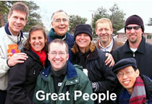
Whether we’re in the U.S. visiting friends and churches who support us, or are in some corner of Latin America at an event for youth leaders or at a meeting, planning and strategizing with other people who train youth leaders, we are invariably surrounded by interesting, committed, engaging people. We can’t believe how lucky we are to have the chance to get to know and to work with such a wide variety of incredible people. Our life is so enriched by them.
The other constant is that there is never enough time to really connect with everyone, to do all we need to do or to even begin to see and experience all we would like to, so the good habits and margin that we so carefully maintain at home ﬂy out the window when we’re on the road. We love to travel and are so thankful that we can have such amazing experiences, but there is always something great about getting back home.
So that’s a day in our life.

Annette & Tim

