As Annette and I were in Ecuador at our “ostrich convention” surrounded by 20 friends and colleagues who also train youth leaders in Latin America…with whom we were dreaming and strategizing on how to be effective catalysts throughout the region in the area of youth work…we were relishing these relationships, that only time and a common passion forge, and we realized that this was the anniversary of our 10th year as missionaries.

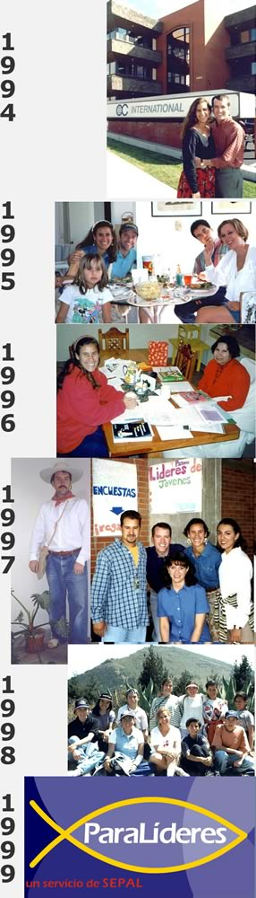
In celebration we decided to present you with an overview of that decade which you – through your prayers and financial support – have made possible.

1994 - Graduated from RTS Seminary with an interest in doing youth ministry outside of the U.S.; we interviewed with and were hired by OC International; and began raising funds.

1995 - Went thru 6 weeks of cross-cultural training in Colorado; chose Mexico over Brazil, Colombia and Romania, sold 80% of our stuff and moved from Orlando to Annette’s parents’ house in Kansas; met our “minimum financial support requirement”; packed to leave for Mexico

1996 - Arrived at the Mexico City airport at 1:00 p.m. on January 1st with 11 bags, boxes and suitcases; got a week of basic life-in-Mexico training then left for 5 months of language learning in Cuernavaca where we lived the whole time with the Martinez family; “graduated” from language school, returned to Toluca where our team is located, continued to learn about Mexico and the youth culture here

1997 - Began doing formal research in which we survey 225 youth leaders and pastors from all over Mexico. Their greatest stated needs were #1) youth ministry resources and #2 ) training.

1998 - Continued research on Mexican youth culture – specifically their values and religious beliefs – polling over 2000 adults and teens; began looking for strategic, cost effective ways to meet the leader’s needs.; woke up one night with the idea of using the Internet as a way to accomplish goal #1

1999 - January 1st at 6:00 a.m. was the Grand Opening of the first Spanish language youth ministry website; it had 100 pages of content and in the first two months saw approximately 1200 visitors; we taught at a few youth ministry conferences around Mexico and continued working with our local youth group, especially in the area of training youth leaders
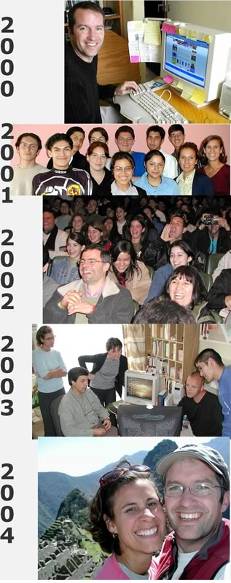
2000 - Continued developing the youth ministry website (it grew to over 1000 pages of materials and had 62,000 visitors); we coordinated, guided, prodded, and praised the team of 10 people who contributed to the site (5 of them paid); taught at youth workers conferences, mentored youth leaders in our city, and continued working with our local church youth group

2001 - Thanks to Xavier Cabezas and Greg Lusk, programmers from the U.S. who donated their time, we upgraded the website in every way, which enabled over 100 people to publish their youth ministry materials on the site, doubling the number of pages available to 2000, increased readership to an average of 13,000/month and let us poll youth leaders from all over Latin America; got involved with the Raíces training movement; began dreaming about and learning how to provided training via the Internet (which if you remember, was goal #2)

2002 - Continued doing all of the above, but focused more time and energy on developing online training courses and less time on teaching youth conferences (we’d trained others in that area and they did it better); accepted an invitation to join the board of the Raíces youth ministry training movements and began traveling all over Latin America as part of that responsibility; the web site again doubled the number of published pages available to 4000, readership increased to 22,000/month, had youth leaders from over 38 countries downloading materials, and saw over 1000 people take our one and only online class

2003 - Developed over a dozen more online, interactive classes and had an average of 1500 people taking one or more of them on an average month; handed over 100% of the responsibility for the local church youth group to the youth leaders we’d helped train; reached 8000 pages of free materials that are available online, tripled readership to an average of 60,000/month; and helped organized 3 Raíces conferences around Mexico (which wore us out)

2004 - Our focus this year has been finishing up the development of a foundation youth ministry course consisting of 21 animated, interactive classes and an accompanying 500-page textbook (which Annette is editing and re-writing); we are traveling a lot more as we our focus continues to grow beyond Mexico to all of Latin American and Spain.

It’s been an adventure that we wouldn’t trade for anything!
Tim & Annette

