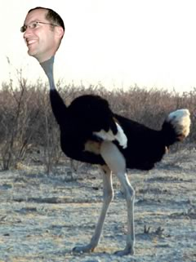
Ostrich Convention

One of the highlights of our year is a meeting with other ostriches and this year it is the first week of Oct. in Quito, Ecuador.

What?!… you didn’t know we’re ostriches? Think about it, what is an ostrich but a bird that can’t fly, which really sounds like an oxymoron. All birds know that to be a bird is to be able to fly, so although we call ostriches “birds” all of the other birds know that they aren’t really birds.

That’s us – we live in Mexico but all Mexicans know we aren’t Mexican, however when we’re in the States we don’t fit in perfectly there either. But the one place we feel perfectly at home is when we’re with other foreigners who live in Latin America and train youth workers: the ostrich convention.

It is actually called “the Latin Summit”, is organized by Russ Cline and Youth World, is attended by about 15 friends and colleagues and has these 3 objectives:
- To build relationships with key youth workers/trainers in Latin America
- To strategize how we can work more closely and effectively together
- To know how to pray and support each other

We could fill up pages with the ways this “Summit” has created synergisms in our ministries, not to mention the personal encouragement and support of these relationships. The first time we met, most of us didn’t know each other...we came from 11 different countries and 10 different ministries, but now we are good friends and most of us are involved in collaborative work with others from the “ostrich convention”

To see pictures and read stories about the trip check out our web log at www.4loves.com/mexitext after the 12th of Oct. If you’d like to stay current on what we’re up to, you can subscribe e-mailings on that same page.


Babbled Translation


Ever read a bad translation?…maybe the instructions which came with your Chinese gadget – “Turns the key in the contrary sense of the needles of timepiece.” Computer assisted translations are often funny, this one is downright heretical. ☺
Annette was reviewing an online version of some Christian book...the guy who translated it obviously leaned heavily on an automatic translator because wherever the name "Holy Spirit" showed up it had been translated into Spanish as "Holy Liquor" (spirits = liquor... see the problem!?) Just imagine when John the Baptist baptized Jesus and the holy liquor descended on him.... or when the disciples were filled with the holy liquor during Pentecost. No wonder the onlookers thought those early Christians were drunk.

