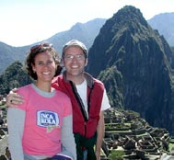
We just got back from Peru. The logistics of the trip went very well – travel was uneventful, the timetable of meetings, the conference, etc. worked well and we were healthy, though tired at times ☺, throughout.

So much happened in the eight days we were gone that I’m at a loss as to where to start telling you about it, but here’s an attempt…

Conference Background

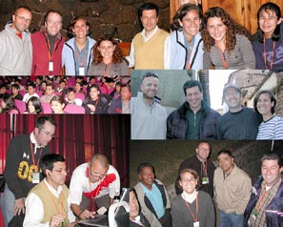
When Eduardo Zuniga took charge recently as the new director in Peru of Compassion International (Christian child sponsorship program, www.compassion.com), he commissioned some research so he could better understand the reality of the project. Some of the findings were startling, including the fact that only 20 percent of teenagers graduating from the program claimed to have a personal relationship with Christ and that many of the churches who work with the Compassion project have little or no ministry available for teens after they graduated from Compassion’s program.

Faced with these sobering realities, Eduardo began to form a groundbreaking plan to fortify the local churches and he chose RAICES (Roots) training for youth leaders as the ministry best suited to provide this training. This is obviously a great privilege… and a great opportunity.

As a result of this collaboration with Compassion, this conference was a watershed in the history of the RAICES: a large percent of the attendees were pastors and for the first time a well organized follow up program will be carried out long after we have left the country. And this could turn out to be a model that Compassion projects in other Latin American countries could choose to follow. (We are already in dialogue with Compassion Ecuador.)

Training for Trainers

In our July letter we explained that a team of five of us had a Herculean effort ahead of us to have fourteen of the animated classes and their accompanying materials ready for the “training for trainers” continuing education aspect of the conference. We felt we needed to reach a certain point in the material before the conference so the students would have classes covering material including the foundational biblical principles of youth ministry and a strategy for their implementation. Despite a few last minute hiccups we got it all done (big hurrah!) and it is such a good thing we did because what we didn’t know is that part of Compassion’s follow-up program would center on these classes.
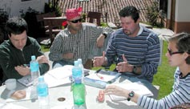
They chose fifteen people who will be the first students in our extension program, going through the animated classes and turning in their homework to an official RAICES tutor. We kicked this program off the last afternoon of the conference when Tim and I explained the program and walked the students through one of the classes. Their response, and that of the other members of the RAICES team, was incredible. For example one of the authors of the material, Felix Ortiz, is currently studying his masters in online education from a prestigious school in Spain and he repeatedly explained to people that he has yet to come across a course as well done as ours.

Quick Stats
8 days we were in Peru

4 cities visited during those days

183 diplomas awarded for successful completion of RAICES training

18 hours spent returning from Lima, Peru to our house in Toluca

8 hours of that travel time actually spend in the air

Incalculable… the joy of seeing what God is doing in the world, of being able to playing a part in that, of hearing people’s effusive response to our classes, of meeting wonderful Peruvian brothers and sisters in Christ and of being with our friends Felix and Gerardo.
We’re excited the course is ready to be used and have a new enthusiasm to finish the remaining six classes.
Long Term Results

A highlight of the trip was getting a glimpse into the fruit this combined effort of Compassion and RAICES could produce.

Raul Ricardo Rodriguez (33 years old) grew up in poor family on the outskirts of Bogota, Colombia. A sponsor through Compassion International provided him with food, clothing and education throughout his childhood and even a technical career as a teenager. He later went to seminary and in 2001 became a RAICES trainer. He is currently the director of small groups and youth ministry at a large church in Bogota (3,500 members) where he supervises a team of volunteers who are working together to minister to the needs of the youth in a truly biblical and pastoral way.


Without his sponsor and Compassion, who knows what would have become of Raul and without RAICES he wouldn’t have the training and tools to create a team of leaders who could really minister to the large number of students he is now responsible for.

Thanks again for your prayers and for partnering with us in this exciting project.

Annette & Tim

